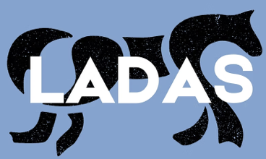
Dear artist,
Thank you for your interest in Lutterworth and District Arts Society. We are delighted that you have considered us.
Membership of this society offers you:
- Quarterly newsletters
- Meetings every six weeks
- Biannual open exhibitions
- 10% discount on picture framing and printing at Lilypad Fine Arts.
MEMBERSHIP FORM
Lutterworth and District Arts Society

I am a new member - (2025/26) ☐

Mr/ Mrs/ Ms: ___________________________________________

Address: _________________________________
_________________________________
_________________________________
_________________________________
Post Code: ______________________________
Phone number: __________________________
Email: ___________________________________

Signature: ______________________________
Date: ___________________________________

MEMBERSHIP FEE:
Individual: £25 ☐
Couple: £45 ☐

BACS payment details:

Acc Name: Lilypad Fine Arts
Sort Code: 04-00-03
Acc Number: 68262460

Membership is valid for 12 months – 1st June 2025 – 31st May 2026

c/o Lilypad Fine Arts Limited
Unit
Archway Gallery
1, Market Street
Lutterworth
LE

BACS payment details:

Acc Name: Lilypad Fine Arts
Sort Code: 04-00-03
Acc Number: 68262460

Membership is valid for 12 months – 1st June 2025 – 31st May 2026

